**IT350: Data Analytics Quiz**

Check List

**Box Plot watch a video**

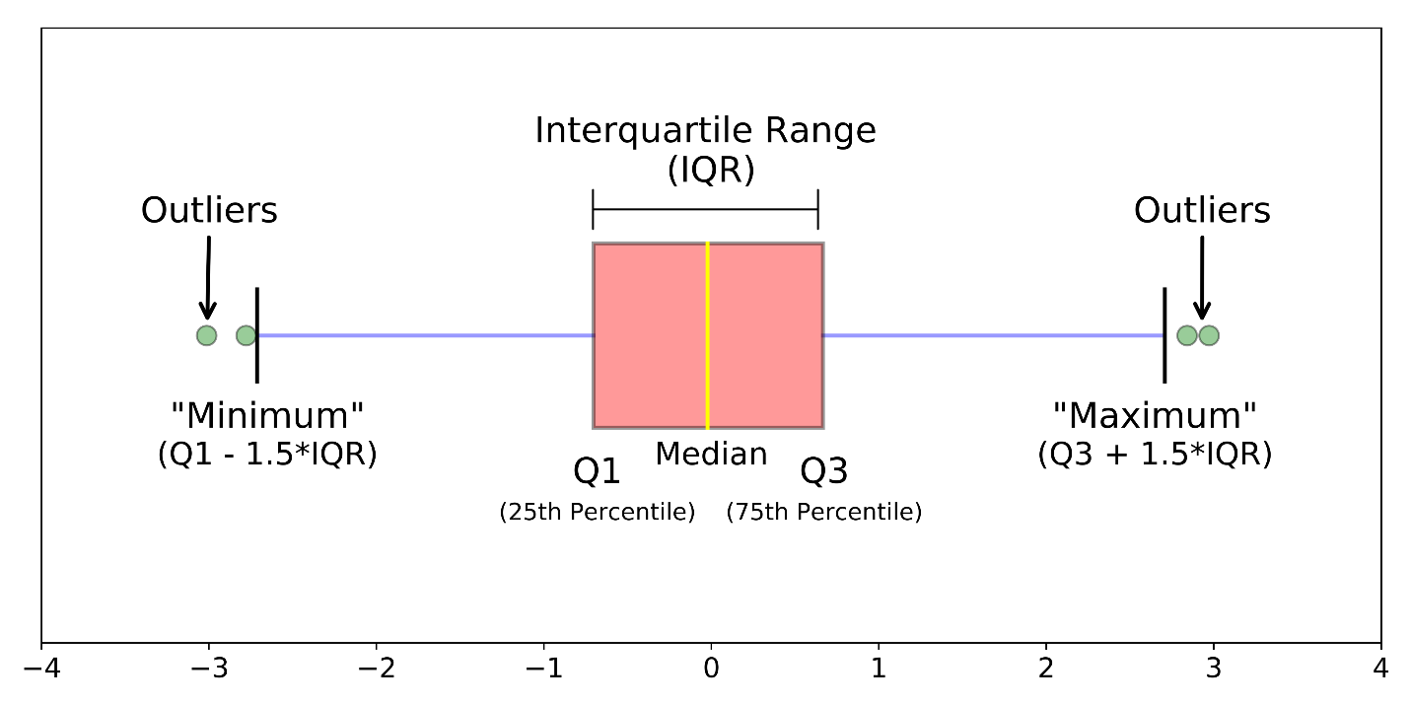

**Stem plot watch a video**

**ANOVA test watch a video**

**How is z table made? What does it indicate?**

**More information on degrees of freedom**

**Two sample z test**

**What does critical value mean?**

**What is Bayesian theory?**

**Why are chi square tests one tailed?**

Chi square tests are one tailed because the test either reaches the threshold or it does not. For all values below the threshold value, you fail to reject the null hypothesis.

Right tailed test only

**Why t tests are for small sample size?**

T-test works on large sample but its value gets closer to z-score. Do not use for skewed data.

**What is single and multiple imputation?**

Single imputation: Single prediction or decision

Multiple imputation: Multiple predictions and then select the best prediction.

**What is p value?**

The p-value is the probability of obtaining test results at least as extreme as the results actually observed. Under the assumption that the null hypothesis is correct.

**Symmetrical data** is when median is approximately equal to mean and second highest mode is almost equal to mean.

Probabilities in z table calculated using the formula:

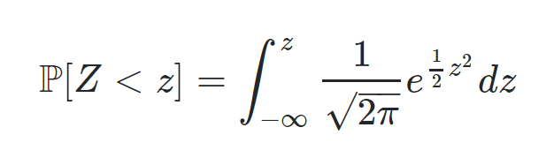

Z table left tailed

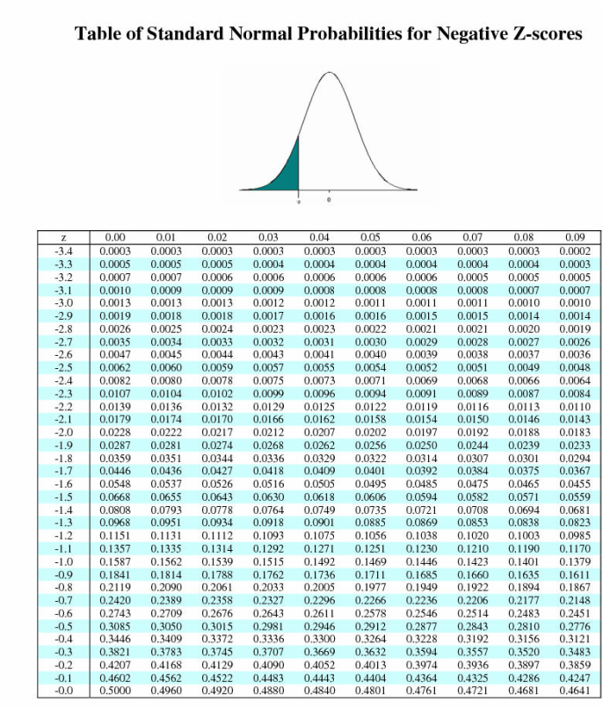

t-table

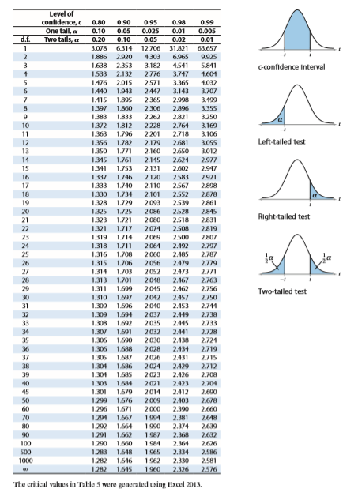

F table

